# Cybersecurity Awareness - Training Document (Training)

## **Topic: Cybersecurity Awareness (*Version:- v1.0)***

### 1. Objective:

The goal of this training is to educate employees on cybersecurity best practices, including how to recognize phishing attempts, protect company data, and use secure passwords. This training will help reduce security risks and ensure data integrity across GreenTree.

---

2. Overview:

Cybersecurity is a critical aspect of modern digital operations. This session provides an introduction to essential topics like email scams, data protection, secure browsing, and reporting incidents. All employees must understand these principles to ensure a safe working environment.

---

3. Key Concepts:

* What is Cybersecurity?
* Common Threats: Phishing, Malware, Ransomware
* Strong Password Creation
* Multi-Factor Authentication (MFA)
* Secure Email Practices
* Reporting Suspicious Activity

---

4. Steps / Instructions:

1. Review the “Cybersecurity Slides (Training).pptx”
2. Watch the company’s internal cybersecurity video (link provided in Teams)
3. Take the Cybersecurity Quiz v1.0
4. Save your quiz result screenshot
5. Read the GreenTree Data Protection Policy document
6. Answer the Reinforcement Questions (see last section)

---

5. Diagrams / Screenshots:

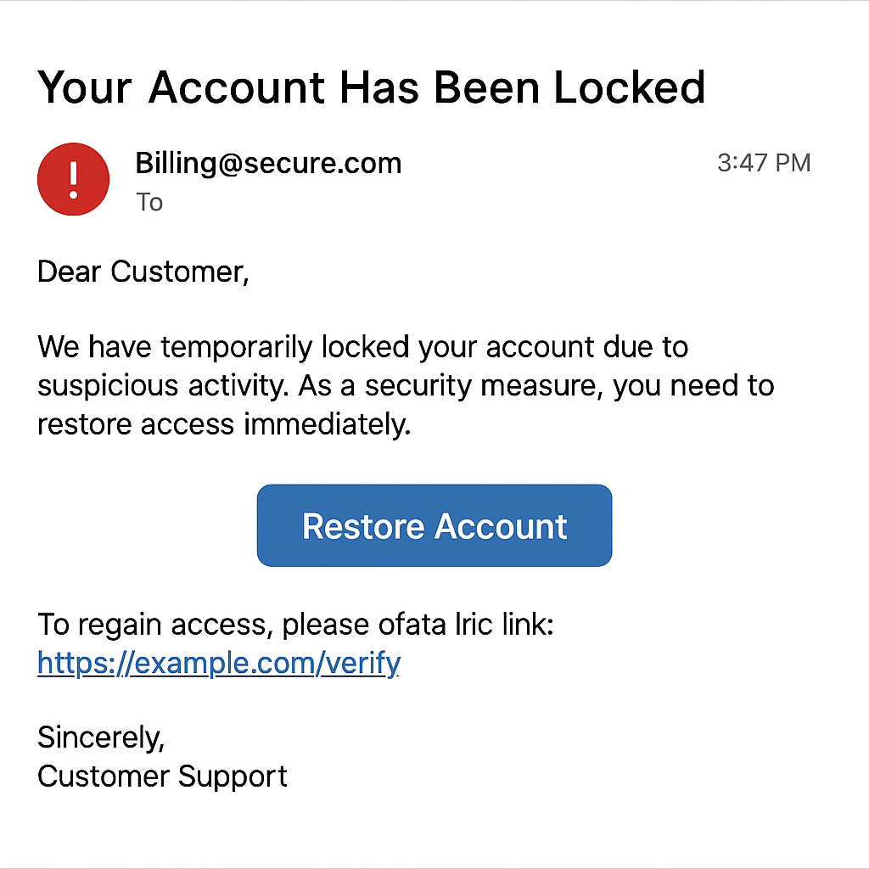

---

6. Notes / Tips:

* Never share your passwords, even with IT staff
* Avoid clicking unknown links or downloading from suspicious emails
* Lock your device when not in use
* Use the VPN when working remotely

---

7. References:

- GreenTree Cybersecurity Policy (v2.0)

- Internal Cybersecurity Awareness Video – Teams > Files > Cybersecurity

- https://www.cyber.gov.in (Govt. of India official portal)